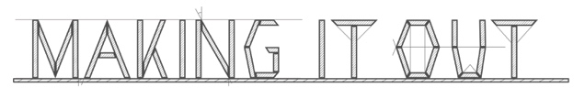
Referral Form for workplace training placements.

IMPORTANT PLEASE READ

Referrer - Please fill in all information that you are able to and send to mark@makingitout.co.uk. If this will contain sensitive information we request that you encrypt the file with a password and send the password in a separate email. Please ensure that you have the permission of the prospective participant to share this information with us.

MIO Staff – If you receive a referral without a password, please protect it immediately and delete the email in which it was sent.
Do not leave referral forms open on a computer and do not read them in the presence of others.

Thank you!

Referral Form for participants at Making It Out

Referrer Details

Agency/Organisation | Name of referrer & service manager
e-mail address of referrer | Contact Number | Working days
Nature of participants relationship with referrer
Is this regarding a prospective ROTL placement? | Yes No

Participant details

Participant Name | Best method of contacting participant (if not through referrer)
Release Date (approx. necessary) | Address (post-release if known, not prison)
Reasons for wanting to work with MiO | Relevant experience (work or training) | Offending history
Long term aims of participant | Possible barriers to engagement | Any other relevant info

The next stage after the referral is usually for us to have an informal interview with the prospective participant. If this is in the community, then this could take place at our studio in Portslade or in a neutral venue. If this the participant is still in prison, then we will arrange a time to visit but this may take a little longer to arrange. We appreciate your patience regarding this and we will be in touch shortly.

Thanks

